SAP-l is a computer because it stores a program and data before calculations begin; then it automatically carries out the program instructions without human intervention. And yet, SAP-l is a primitive computing machine. It compares to a modem computer the way a Neanderthal human would compare to a modem person. Something is missing, something found in every modem computer. SAP-2 is the next step in the evolution toward modem computers because it includes jump instructions. These new instructions force the computer to repeat or skip part of a program. As you will discover, jump instructions open up a whole new world of computing power.

11-1 BIDIRECTIONAL REGISTERS

To reduce the wiring capacitance of SAP-2, we will run only one set of wires between each register and the bus. Figure 11-la shows the idea. The input and output pins are shorted; only one group of wires is connected to the bus. Does this shorting the input and output pins ever cause trouble? No. During a computer run, either LOAD or ENABLE may be active, but not both at the same time. An active LOAD means that a binary word flows from the bus to the register input; during a load operation, the output lines are floating. On the other hand, an active ENABLE means that a binary word flows from the register to the bus; in this case, the input lines float. The IC manufacturer can internally connect the input and output pins of a three-state register. This not only reduces the wiring capacitance; it also reduces the number of 110 pins. For instance, Fig. ll-lb has four 110 pins instead of eight. Figure II-Ie is the symbol for a three-state register with internally connected input and output pins. The doubleheaded arrow reminds us that the path is bidirectional; data can move either way.

11-2 ARCHITECTURE

Figure 11-2 shows the architecture of SAP-2. All register outputs to the W bus are three state; those not connected to the bus are two-state. As before, the controller-sequencer sends control signals (not shown) to each register. These control signals load, enable, or otherwise prepare the register for the next positive clock edge. A brief description of each box is given now.

Input Ports

SAP-2 has two input ports, numbered 1 and 2. A hexadecimal keyboard encoder is connected to port 1. It allows us to enter hexadecimal instructions and data through port

1. Notice that the hexadecimal keyboard encoder sends a READY signal to bit 0 of port 2. This signal indicates when the data in port 1 is valid. Also notice the SERIAL IN signal going to pin 7 of port
2. A later example will show you how to convert serial input data to parallel data.

Program Counter

This time, the program counter has 16 bits; therefore, it can count from

PC = 0000 0000 0000 0000
to
PC = 1111 1111 1111 1111

This is equivalent to OOOOHto FFFFH, or decimal 0 to 65,535. A low CLR signal resets the PC before each computer run; so the data processing starts with the instruction stored in memory location OOOOH.

Fig. 11·1 Bidirectional register.

MAR and Memory

During the fetch cycle, the MAR receives lti-bit addresses from the program counter. The two-state MAR output then addresses the desired memory location. The memory has a 2K ROM with addresses of OOOOHto 07FFH. This ROM contains a program called a monitor that initializes the computer on power-up, interprets the keyboard inputs, and so forth. The rest of the memory is a 62K RAM with addresses from 0800H to FFFFH.

Memory Data Register

The memory data register (MDR) is an 8-bit buffer register. Its output sets up the RAM. The memory data register receives data from the bus before a write operation, and it sends data to the bus after a read operation.

Instruction Register

Because SAP-2 has more instructions than SAP-I, we will use 8 bits for the op code rather than 4. An 8-bit op code can accommodate 256 instructions. SAP-2 has only 42 instructions, so there will be no problem coding them with 8 bits. Using an 8-bit op code also allows upward compatibility with the 8080/8085 instruction set because it is based on an 8-bit op code. As mentioned earlier, all SAP instructions are identical with 8080/8085 instructions.

Controller-Sequencer

The controller-sequencer produces the control words or microinstructions that coordinate and direct the rest of the computer. Because SAP-2 has a bigger instruction set, the controller-sequencer has more hardware. Although the CON word is bigger, the idea is the same: the control word or microinstruction determines how the registers react to the next positive clock edge.

Accumulator

The two-state output of the accumulator goes to the ALU; the three-state output to the W bus. Therefore, the 8-bit word in the accumulator continuously drives the ALU, but this same word appears on the bus only when EA is active.

Fig. 11-2 SAP-2 block architecture.

ALU and Flags

Standard ALUs are commercially available as integrated circuits. These ALUs have 4 or more control bits that determine the arithmetic or logic operation performed on words A and B. The ALU used in SAP-2 includes arithmetic and logic operations. In this book a flag is a flip-flop that keeps track of a changing condition during a computer run. The SAP-2 computer has two flags. The sign flag is set when the accumulator contents become negative during the execution of some instructions. The zero flag is set when the accumulator contents become zero.

TMP, B, and C Registers

Instead of using the B register to hold the data being added or subtracted from the accumulator, a temporary (TMP) register is used. This allows us more freedom in using the B register. Besides the TMP and B registers, SAP-2 includes a C register. This gives us more flexibility in moving data during a computer run.

Output Ports

SAP-2 has two output ports, numbered 3 and 4. The of the accumulator can be loaded into port 3, which drives a hexadecimal display. This allows us to see the processed data.
The contents of the accumulator can also be sent to port 4. Notice that pin 7 of port 4 sends an ACKNOWLEDGE signal to the hexadecimal encoder. This ACKNOWLEDGE signal and the READY signal are part of a concept called handshaking, to be discussed later.
Also notice the SERIAL OUT signal from pin 0 of port 4; one of the examples will show you how to convert parallel data in the accumulator into serial output data.

11-3 MEMORY-REFERENCE
INSTRUCTIONS

The SAP-2 fetch cycle is the same as before. T] is the address state, T2 is the increment state, and T3 is the memory state. All SAP-2 instructions therefore use the memory during the fetch cycle because a program instruction is transferred from the memory to the instruction register.
During the execution cycle, however, the memory may or may not be used; it depends on the type of instruction that has been fetched. A memory-reference instruction (MRI) is one that uses the memory during the execution cycle.
The SAP-2 computer has an instruction set with 42 instructions. What follows is a description of the memory reference instructions.

LDA and STA

LDA has the same meaning as before: load the accumulator with the addressed memory data. The only difference is that more memory locations can be accessed in SAP-2 because the addresses are from OOOOH to FFFFH. For example, LDA 2000H means to load the accumulator with the contents of memory location 2000H.
To distinguish the different parts of an instruction, the mnemonic is sometimes called the op code and the rest of the instruction is known as the operand. With LDA 2000H, LDA is the op code and 2000H is the operand. Therefore, "op code" has a double meaning in microprocessor work; it may stand for the mnemonic or for the binary code used to represent the mnemonic. The intended meaning is clear from the context.
STA is a mnemonic for store the accumulator. Every STA instruction needs an address. STA 7FFFH means to store the accumulator contents at memory location 7FFFH.
If
A = 8AH

the execution of STA 7FFFH stores 8AH at address 7FFFH.

MVI

MVI is the mnemonic for move immediate. It tells the computer to load a designated register with the byte that immediately follows the op code. For instance,

MVI A,37H

tells the computer to load the accumulator with 37H. After this instruction has been executed, the binary contents of the accumulator are

A = 0011 0111

You can use MVI with the A, B, and C registers. The formats for these instructions are

MVI A,byte
MVI B,byte
MVI C,byte

Op Codes

Table 11-1 shows the op codes for the SAP-2 instruction set. These are the 8080/8085 op codes. As you can see, 3A is the op code for LDA, 32 is the op code for STA, etc. Refer to this table in the remainder of this chapter.

EXAMPLE 11-1
Show the mnemonics for a program that loads the accumulator with 49H, the B register with 4AH, and the C register with 4BH; then have the program store the accumulator data at memory location 6285H.

SOLUTION
Here's one program that will work:

Mnemonics
MVIA,49H
MVIB,4AH
MVIC,4BH
STA 6285H
HLT

The first three instructions load 49H, 4AH, and 4BH into the A, B, and C registers. STA6285H stores the accumulator contents at 6285H.
Note the use of HLT in this program. It has the same meaning as before: halt the data processing.

TABLE 11-1. SAP-2 OP CODES

Instruction Op Code Instruction Op Code

ADD B 80 MOV B,A 47
ADD C 81 MOV B,C 41
ANA B AO MOV C,A 4F
ANA C Al MOV C,B 48
ANI byte E6 MVI A,byte 3E
CALL address CD MVI B,byte 06
CMA 2F MVI C,byte OE
DCR A 3D NOP 00
DCR B 05 ORA B BO
DCR C OD ORAC Bl
HLT 76 ORI byte F6
IN byte DB OUT byte D3
INR A 3C RAL 17
INR B 04 RAR IF
INR C OC RET C9
JM address FA STA address 32
JMP address C3 SUB B 90
JNZ address C2 SUB C 91
JZ address CA XRA B A8
LDA address 3A XRA C A9
MOV A,B 78 XRI byte EE
MOV A,C 79

EXAMPLE 11-2
Translate the foregoing program into 8080/8085 machine language using the op codes of Table 11-1. Start with address 2000H.

SOLUTION

Address Contents Symbolic
2000H 3EH MVI A,49H
200lH 49H
2002H 06H MVIB,4AH
2003H 4AH
2004H OEH MVI C,4BH
2005H 4BH
2006H 32H STA 6285H
2007H 85H
2008H 62H
2009H 76H HLT

There are a couple of new ideas in this machine-language program. With the

MYI A,49H
instruction, notice that the op code goes into the first address and the byte into the second address. This is true of all 2- byte instructions: op code into the first available memory location and byte into the next. The instruction

STA 6285H

is a 3-byte instruction (1 byte for the op code and 2 for the address). The op code for STA is 32H. This byte goes into the first available memory location, which is 2006H. The address 6285H has 2 bytes. The lower byte 85H goes into the next memory location, and the upper byte 62H into the next location.
Why does the address get programmed with the lower byte first and the upper byte second? This is a peculiarity of the original 8080 design. To keep upward compatibility, the 8085 and some other microprocessors use the same scheme: lower byte into lower memory, upper byte into upper memory.
The last instruction HLT has an op code of 76H, stored in memory location 2009H. In summary, the MVI instructions are 2-byte instructions, the STA is a 3-byte instruction, and the HLT is a I-byte instruction.

11·4 REGISTER INSTRUCTIONS

Memory-reference instructions are relatively slow becausethey require more than one memory access during the instruction cycle. Furthermore, we often want to move data directly from one register to another without having to go through the memory. What follows are some of the SAP2 register instructions, designed to move data from one register to another in the shortest possible time.

MOV

MOV is the mnemonic for move. It tells the computer to move data from one register to another. For instance, MOV A,B tells the computer to move the data in the B register to the accumulator. The operation is nondestructive, meaning that the data in B is copied but not erased. For example, if A = 34H and B= 9DH then the execution of MOY A,B results in

A = 9DH
B = 9DH

You can move data between the A, B, and C registers. The formats for all MOY instructions are

MOYA,B
MOYA,C
MOYB,A
MOYB,C
MOYC,A
MOYC,B

These instructions are the fastest in the SAP-2 instruction
set, requiring only one machine cycle.

ADD and SUB

ADD stands for add the data in the designated register to the accumulator. For instance,

ADDB

means to add the contents of the B register to the accumulator. If

A = 04H and B= 02H

then the execution of ADD B results in A = 06H Similarly, SUB means subtract the data in the designated register from the accumulator. SUB C will subtract the contents of the C register from the accumulator. The formats for the ADD and SUB instructions are

ADDB
ADDC
SUBB
SUBC

INR and DCR

Many times we want to increment or decrement the contents of one of the registers. INR is the mnemonic for increment; it tells the computer to increment the designated register. DCR is the mnemonic for decrement, and it instructs the computer to decrement the designated register. The formats for these instructions are

INR A
INR B
INR C
DCR A
DCR B
DCR C

As an example, if

B = 56H and C = 8AH

then the execution of INR B results in

B= 57H

and the execution of a DCR C produces

C = 89H

EXAMPLE 11-3

Show the mnemonics for adding decimal 23 and 45. The answer is to be stored at memory location 5600H. Also, the answer incremented by I is to be stored in the C register.

SOLUTION
As shown in Appendix 2, decimal 23 and 45 are equivalent to 17H and 2DH. Here is a program that will do the job:

Mnemonics

MYIA,17H
MYIB,2DH
ADD B
STA5600H
INR A
MOYC,A
HLT

EXAMPLE 11-4

To hand-assemble a program means to translate a source program into a machine-language program by hand rather than machine. Hand-assemble the program of the preceding example starting at address 2000H.

SOLUTION

Address Contents Symbolic
2000H 3EH MYI A,17H
200lH 17H
2002H 06H MYI B,2DH
2003H 2DH
2004H 80H ADDB
2005H 32H STA 5600H
2006H OOH
2007H 56H
2008H 3CH INRA
2009H 4FH MOY C,A
200AH 76H HLT

Notice that the ADD, INR, MOY, and HLT instructions are l-byte instructions; the MYI instructions are 2-byte instructions, and the STA is a 3-byte instruction.

11-5 JUMP AND CALL
INSTRUCTIONS

SAP-2 has four jump instructions; these can change the program sequence. In other words, instead of fetching the next instruction in the usual way, the computer may jump or branch to another part of the program.

JMP

To begin with, JMP is the mnemonic for jump; it tells the computer to get the next instruction from the designated memory location. Every JMP instruction includes an address that is loaded into the program counter. For instance,

JMP 3000H

tells the computer to get the next instruction from memory location 3000H.

Fig. 11-3(a) Unconditionaljump; (b) conditionaljump.

Here is what happens. Suppose JMP 3000H is stored at 2005H, as shown in Fig. 11-3a. At the end of the fetch cycle, the program counter contains

PC = 2006H

During the execution cycle, the JMP 3000H loads the program counter with the designated address:

PC = 3000H

When the next fetch cycle begins, the next instruction comes from 3000H rather than 2006H (see Fig. 11-3a).

JM

SAP-2 has two flags called the sign flag and the zero flag. During the execution of some instructions, these flags will be set or reset, depending on what happens to the accumulator contents. If the accumulator contents become negative, the sign flag will be set; otherwise, the sign flag is cleared. Symbolically,

where S stands for sign flag. The sign flag will remain set or clear until another operation that affects the flag. JM is a mnemonic for jump if minus; the computer will jump to a designated address if and only if the sign flag is set. As an example, suppose a JM 3000H is stored at 2005H. After this instruction has been fetched,

PC = 2006H

If S = 1, the execution of JM 3000H loads the program counter with

PC = 3000H

Since the program counter now points to 3000H, the nextinstruction will come from 3000H.
If the jump condition is not met (S = 0), the program counter is unchanged during the execution cycle. Therefore, when the next fetch cycle begins, the instruction is fetched from 2006H.
Figure 11-3b symbolizes the two possibilities for a JM instruction. If the minus condition is satisfied, the computer jumps to 3000H for the next instruction. If the minus condition is not satisfied, the program falls through to the next instruction.

JZ

The other flag affected by accumulator operations is the zero flag. During the execution of some instructions, the accumulator will become zero. To record this event, the zero flag is set; if the accumulator contents do not go to zero, the zero flag is reset. Symbolically,

JZ is the mnemonic for jump if zero; it tells the computer to jump to the designated address only if the zero flag is set. Suppose a JZ 3000H is stored at 2005H. If Z = 1 during the execution of JZ 3000H, the next instruction is fetched from 3000H. On the other hand, if Z = 0, the next instruction will come from 2006H.

JNZ

JNZ stands for jump if not zero. In this case, we get a jump when the zero flag is clear and no jump when it is set. Suppose a JNZ 7800H is stored at 2100H. If Z = 0, the next instruction will come from 7800H; however, if Z = 1, the program falls through to the instruction at 2101H.
JM, JZ, and JNZ are called conditional jumps because the program jump occurs only if certain conditions are satisfied. On the other hand, JMP is unconditional; once this instruction is fetched, the execution cycle always jumps the program to the specified address.

CALL and RET

A subroutine is a program stored in the memory for possible use in another program. Many microcomputers have sub routines for finding sines, cosines, tangents, logarithms, square roots, etc. These subroutines are part of the software supplied with the computer.
CALL is the mnemonic for call the subroutine. Every CALL instruction must include the starting address of the desired subroutine. For instance, if a square-root subroutine starts at address 5000H and a logarithm subroutine at 6000H, the execution of

CALL 5000H

will jump to the square-root subroutine. On the other hand, a

CALL 6000H

produces a jump to the logarithm subroutine.
RET stands for return. It is used at the end of every subroutine to tell the computer to go back to the original program. A RET instruction is to a subroutine as a HLT is to a program. Both tell the computer that something is finished. If you forget to use a RET at the end of a subroutine, the computer cannot get back to the original program and you will get computer trash.
When a CALL is executed in the SAP-2 computer, the contents of the program counter are automatically saved in memory locations FFFEH and FFFFH (the last two memory locations). The CALL address is then loaded into the

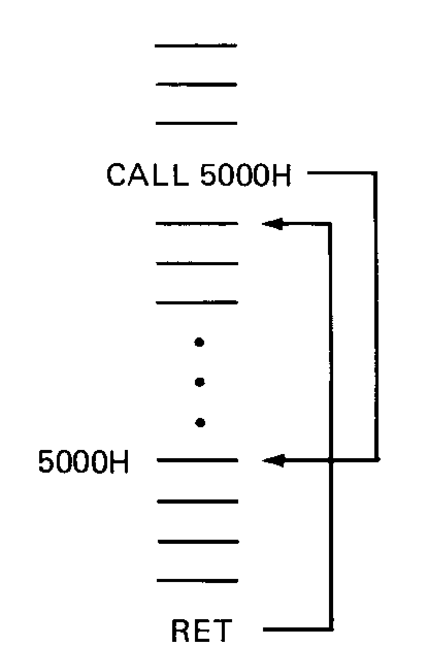

Fig. 11-4 Call Instruction

program counter, so that execution begins with the first instruction in the subroutine. After the subroutine is finished, the RET instruction causes the address in memory locations FFFEH and FFFFH to be loaded back into the program counter. This returns control to the original program.
Figure 11-4 shows the program flow during a subroutine. The CALL 5000H sends the computer to the subroutine located at 5000H. After this subroutine has been completed, the RET sends the computer back to the instruction following the CALL.
CALL is unconditional, like JMP. Once a CALL has been fetched into the instruction register, the computer will jump to the starting address of the subroutine.

More on Flags

The sign or zero flag may be set or reset during certain instructions. Table 11-2 lists the SAP-2 instructions that can affect the flags. All these instructions use the accumulator during the execution cycle. If the accumulator goes negative or zero while one of these instructions is being executed, the sign or zero flag will be set.
For instance, suppose the instruction is ADD C. The contents of the C register are added to the accumulator contents. If the accumulator contents become negative or zero in the process, the sign or zero flag will be set.
A word about the INR and DCR instructions. Since these instructions use the accumulator to add or subtract 1 from the designated register, they also affect the flags. For instance, to execute a DCR C, the contents of the C register are decremented by sending these contents to the accumulator, subtracting I, and sending the result back to the C register. If the accumulator goes negative while the DCRC is executed, the sign flag is set; if the accumulator goes to zero, the zero flag is set.

TABLE 11-2. INSTRUCTIONS
AFFECTING FLAGS
Instruction Flags Affected
ADD S, Z
SUB S, Z
INR S, Z
DCR S, Z
ANA S, Z
ORA S, Z
XRA S, Z
ANI S, Z
ORI S, Z
XRI S, Z

Example 11.5
Hand – assemble the following program starting at the address at 2000H.
MVI C, 03H
DCR C
JZ 0009H
JMP 0002H
HLT

SOLUTION
Address Contents Symbolic
2000H OEH MVI C, 03H
200m 03H
2002H ODH DCRC
2003H CAH JZ 2009H
2004H 09H
2005H 20H
2006H C3H JMP 2002H
2007H 02H
2008H 20H
2009H 76H HLT

EXAMPLE 11 – 6
In the foregoing program, how many times is DCR instruction executed?

SOLUTION
Figure 11-5 illustrates the program flow. Here is what happens. The MVI C, 03H instruction loads the C register with 03h. DCR C reduces the contents to 02H. The contents are greater than zero, therefore, the zero flag is reset, and the JZ, 2009H is ignored. The JMP 2002H returns the computer to the DCR C instruction.
The second time the DCR C is executed, the contents drop to OlH; the zero flag is still reset. JZ 2009H is again ignored, and the JMP 2002H returns the computer to DCR C.
The third DCR C reduces the contents to zero. This time the zero flag is set, and the JZ 2009H jumps the program to HLT instruction.
A loop is part of a program that is repeated. In this example, we have passed through the loop (DCR C and JZ 2009H) 3 times, as shown in Fig. 11-5. Note that the number of passes through the loop equals the number initially loaded into the C register. If we change the first instruction to

MVI C, 07H

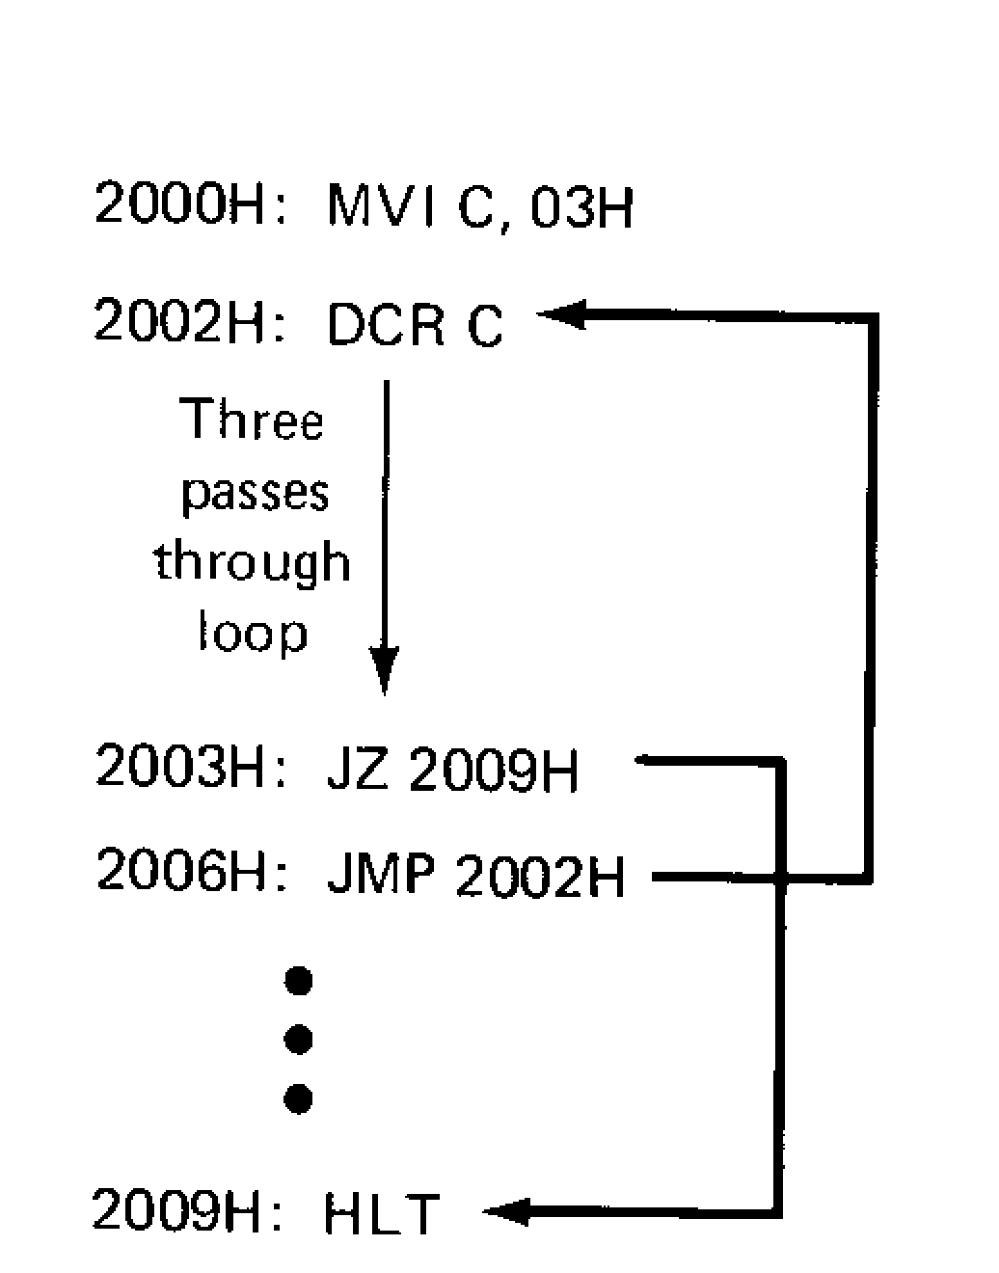

Fig. 11.5 Looping
the computer will loop 7 times. Similarly, if we wanted to pass through the loop 200 times (equivalent to C8H), the first instruction would be
MVI C, C8H

The C register acts like a presettable down counter. This is why it is sometimes referred to as a counter.
The point to remember is this. We can set up a loop by using an MVI, DCR, JZ, and JMP in a program. The number loaded into the designated register (the counter) determines the number of passes through the loop. If we put new instructions inside the loop, these added instructions will be executed Xtimes, the number preset into the counter.

EXAMPLE 11-7

When you buy a microcomputer, you often purchase software to do different jobs. One of the programs you can buy is an assembler. The assembler allows you to write programs in mnemonic form. Then the assembler converts these mnemonics into machine language. In other words, if you have an assembler, you no longer have to hand assemble your programs; the computer does the work for you.
Show the assembly-language version of the program in Example 11-5. Include labels and comments.

SOLUTION
Label Instruction Comment
MVI C, 03H .Load counter with decimal.3
REPEAT: DCR C .Decrement counter
JZ END .Test for zero
JMP REPEAT ; Do it again
END: HLT

When you write a program, it helps to include your own comments about what the instruction is supposed to do. These comments jog your memory if you have to read the program months later. The first comment reminds us that we are presetting the down counter with decimal 3, the second comment reminds us that we are decrementing the counter, the third comment tells us that we are testing for zero before jumping, and the fourth comment tells us that the program will loop back.
When the assembler converts your source program into an object program, it ignores everything after the semicolon. Why? Because that's the way the assembler program is written. The semicolon is a coded way to tell the computer that your personal comments follow. (Remember the ASCII code. 3BH is the ASCII for a semicolon. When the assembler encounters 3BH in your source programs, it knows com
ments follow.)
Labels are another programming aid used with jumps and calls. When we write an assembly-language program, we often have no idea what address to use in a jump or call instruction. By using a label instead of a numerical address we can write programs that make sense to us. The assembler will keep track of our labels and automatically assign the correct addresses to them. This is a great laborsaving feature of an assembler.
For instance, when the assembler converts the foregoing program to machine language, it will replace JZ by CA (op code of Table 11-1) and END by the address of the HLT instruction. Likewise, it will replace JMP by C3 (op code) and REPEAT by the address of the DCR C instruction. The assembler determines the addresses of the HLT and JMP by counting the number of bytes needed by all instructions and figuring out where the HLT and DCR C instructions will be in the final assembled program.
All you have to remember is that you can make up any label you want for jump and call instructions. The same label followed by a colon is placed in front of the instruction you are trying to jump to. When the assembler converts your program into machine language, the colon tells it a
label is involved.
One more point about labels. With SAP-2, the labels can be from one to six characters, the first of which must be a letter. Labels are usually words or abbreviations, but numbers can be included. The following are examples of acceptable labels:

REPEAT
DELAY
RDKBD
A34
B12C3

The first two are words; the third is an abbreviation for read the keyboard. The last two are labels that include numbers. The restrictions on length (no more than six characters) and starting character (must be letter) are typical of commercially available assemblers.

EXAMPLE 11-8

Show a program that multiplies decimal 12 and 8.

SOLUTION

The hexadecimal equivalents of 12 and 8 are OCH and 08H. Let us set up a loop that adds 12 to the accumulator during each pass. If the computer loops 8 times, the accumulator contents will equal 96 (decimal) at the end of the looping. Here's one assembly-language program that will do the job:

Label Mnemonic Comment
MYI A,OOH ;Clear accumulator
MYI B,OCH ;Load decimal 12 into B
8MYI C,08H .Preset counter with
REPEAT: ADD B ;Add decimal 12
DCRC ;Decrement the counter
JZ DONE ;Test for zero
JMP REPEAT ;Do it again
DONE: HLT ;Stop it

The comments tell most of the story. First, we clear the accumulator. Next, we load decimal 12 into the B register. Then the counter is preset to decimal 8. These first three instructions are part of the initialization before entering a loop.
The ADD B begins the loop by adding decimal 12 to accumulator. The DCR C reduces the count to 7. Since the zero flag is clear, JZ DONE is ignored the first time through and the program flow returns to the ADD B instruction.
You should be able to see what will happen. ADD B is inside the loop and will be executed 8 times. After eight passes through the loop, the zero flag is set; then the JZ DONE will take the program out of the loop to the HLT instruction.
Since 12 is added 8 times,

12 + 12 + 12 + 12 + 12 + 12 + 12 + 12 = 96

(Because decimal 96 is equivalent to hexadecimal 60, the accumulator contains 0110 0000.) Repeated addition like this is equivalent to multiplication. In other words, adding 12 eight times is identical to 12 x 8. Most microprocessors do not have multiplication hardware; they only have an adder-subtracter like the SAP computer. Therefore, with the typical microprocessor, you have to use some form of programmed multiplication such as repeated addition.

EXAMPLE 11-9

Modify the foregoing multiply program by using a JNZ instead of a JZ.

SOLUTION

Label Mnemonic Comment

MYI A,OOH ;Clear accumulator
MYI B,OCH ;Load decimal 12 into B
MYI C,08H ;Preset counter with 8
REPEAT: ADDB ;Add decimal 12
DCRC ;Decrement the counter
JNZ REPEAT ;Test for zero
HLT ;Stop it

This is simpler. It eliminates one JMP instruction and one label. As long as the counter is greater than zero, the JNZ will force the computer to loop back to REPEAT. When the counter drops to zero, the program will fall through the JNZ to the HLT.

EXAMPLE 11-10

Hand-assemble the foregoing program starting at address 2000H.

SOLUTION

Address Contents Symbolic
2000H 3EH MYI A,OOH
200lH OOH
2OO2H 06H MVI B,OCH
2OO3H OCH
2OO4H OEH MVI, C,08H
2OO5H 08H
2OO6H 80H ADDB
2OO7H ODH DCRC
2OO8H C2H JNZ
2OO6H
2OO9H 06H
200AH 20H
200BH 76H HLT
The first three instructions initialize the registers before the multiplication begins. If we change the initial values, we can multiply other numbers.

EXAMPLE 11-11

Change the multiplication part of the foregoing program into a subroutine located at starting address F006H.

SOLUTION

Address Contents Symbolic
FOO6H 80H ADDB
FOO7H ODH DCRC
FOO8H C2H JNZ
FOO9H 06H
FOOAH FOH
FOOBH C9H RET

Here's what happened. The initializing instructions depend on the numbers we are multiplying, so they don't belong in the subroutine. The subroutine should contain only the multiplication part of the program. In relocating the program we mapped (converted) addresses 2006H-200BH to F006H-FOOBH. Also, the HLT was changed to a RET to get us back to the original program.

EXAMPLE 11-12

The multiply subroutine of the preceding example is used the following program. What does the program do?
MYIA,OOH
MVI B,10H
MVIC,OEH
CALL F006H
HLT

SOLUTION

Hexadecimal 10H is equivalent to decimal 16, and hexadecimal OEH is equivalent to decimal 14. The first three instructions clear the accumulator, load the B register with decimal 16, and preset the counter to decimal 14. The CALL sends the computer to the multiply subroutine of the preceding example. When the RET is executed, the accumulator contents are EOH, which is equivalent to 224.
Incidentally, a parameter is a piece of data that the subroutine needs to work properly. The multiply subroutine located at F006H needs three parameters to work properly (A, B, and C). We pass these parameters to the multiply subroutine by clearing the accumulator, loading the B register with the multiplicand, and presetting the C register with the multiplier. In other words, we set A = OOH, B = 10H, and C = OEH. Passing data to a subroutine in this way is called register parameter passing.

11-6 LOGIC INSTRUCTIONS

A microprocessor can do logic as well as arithmetic. What follows are the SAP-2 logic instructions. Again, they are a subset of the 8080/8085 instructions.

CMA

CMA stands for "complement the accumulator." The execution of a CMA inverts each bit in the accumulator, producing the 1's complement.

ANA

ANA means to ANDthe accumulator contents with the designated register. The result is stored in the accumulator. For instance,

ANAB

means to ANDthe contents of the accumulator with the contents of the B register. The ANDingis done on a bit-by bit basis. For example, suppose the two registers contain

A = 1100 1100 (11-1)

and

B = 1111 0001 (11-2)

The execution of an ANA B results in

A = 11000000

Notice that the ANDingis bitwise, as illustrated in Fig. 11-6. The ANDingis done on pairs of bits; A7 is ANDed with B7, A6 with B6, As with Bs, and so on, with the result stored in the accumulator. Two ANA instructions are available in SAP-2: ANA B and ANA C. Table 11-1 shows the op codes.

ORA

ORA is the mnemonic for OR the accumulator with the designated register. The two ORA instructions in SAP-2 are ORA B and ORA C. As an example, if the accumulator and B register contents are given by Eqs. ll-1 and ll-2, then executing ORA B gives

A = Ill1 1101

XRA

XRA means XOR the accumulator with the designated register. The SAP-2 instruction set contains XRA Band
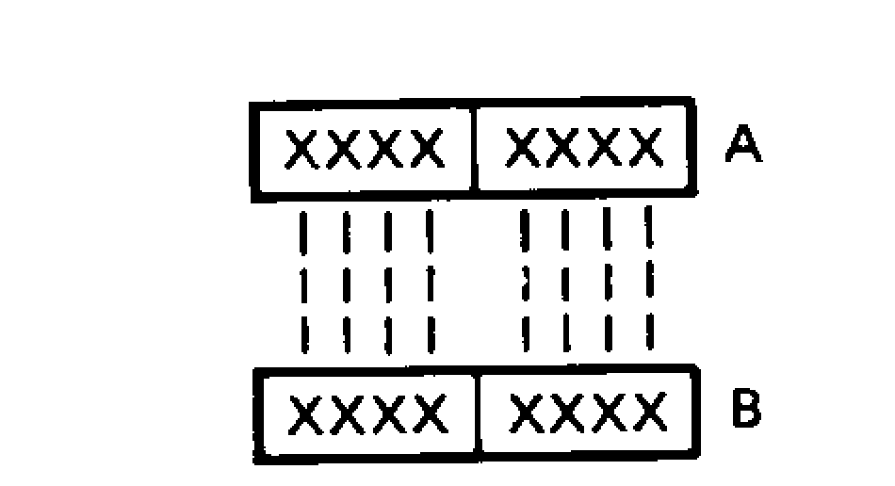
Fig. 11-6 Logic instructions are bitwise.
XRA C. If the accumulator and B contents are given by Eqs. 11-1 and 11-2, the execution of XRA B produces

A = 001l 1101

ANI

SAP-2 also has immediate logic instructions. ANI means ANDimmediate. It tells the computer to ANDthe accumulator contents with the byte that immediately follows the op code. For instance, if

A = 0101 1110

the execution of ANI C7H will AND

0101 1110 with 11000111

to produce new accumulator contents of

A = 01000110

ORI

OR! is the mnemonic for OR immediate. The accumulator contents are oned with the byte that follows the op code. If

A = 0011 1000

the execution of OR! 5AH will OR

0011 1000 with 0101 1010

to produce new accumulator contents of

0111 1010

XRI

XRI means XOR immediate. If

A=OOOI 1100

the execution of XRI D4H will XOR

0001 1100 with 1101 0100

to produce

A= 11001000

11-7 OTHER INSTRUCTIONS

This section looks at the last of the SAP-2 instructions. Since these instructions don't fit any particular category, they are being collected here in a miscellaneous group.

NOP

NOP stands for no operation. During the execution of a NOP, all T states are do nothings. Therefore, no register changes occur during a NOP.
The NOP instruction is used to waste time. It takes four T states to fetch and execute the NOP instruction. By repeating a NOP a number of times, we can delay the data
processing, which is useful in timing operations. For instance, if we put a NOP inside a loop and execute it 100 times, we create a time delay of 400 T states.

HLT

We have already used this. HLT stands for halt. It ends the data processing.

IN

IN is the mnemonic for input. It tells the computer to transfer data from the designated port to the accumulator. Since there are two input ports, you have to designate which one is being used. The format for an input operation is

IN byte

For instance,

IN 02H

means to transfer the data in port 2 to the accumulator.

OUT

OUT stands for output. When this instruction is executed, the accumulator word is loaded into the designated output port. The format for this instruction is

OUT byte

Since the output ports are numbered 3 and 4 (Fig. 11-2), you have to specify which port is to be used. For instance,

OUT 03H

will transfer the contents of the accumulator to port 3.

RAL

RAL is the mnemonic for rotate the accumulator left. This instruction will shift all bits to the left and move the MSB
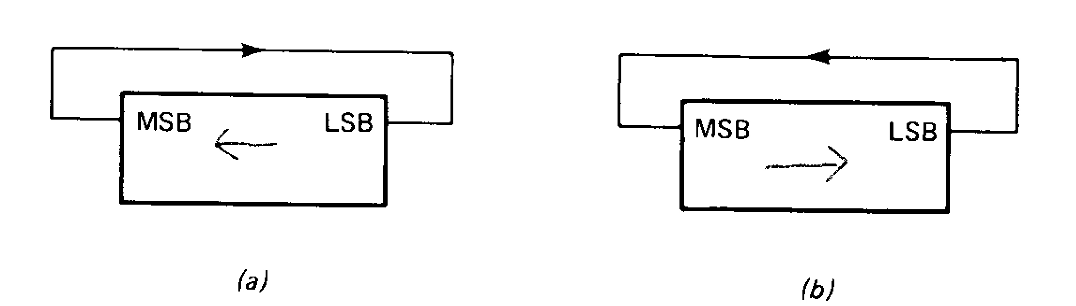

Fig. 11-7 Rotate instructions: (a) RAL; (b) RAR.

into the LSB position, as illustrated in Fig. 11-7a. As an example, suppose the contents of the accumulator are

A= 1011 0100

Executing the RAL will produce

A = 01101001

As you see, all bits moved left, and the MSB went to the LSB position.

RAR

RAR stands for rotate the accumulator right. This time, the bits shift to the right, the LSB going to the MSB position, as shown in Fig. 11-7b. If

A = 10110100

the execution of a RAR will result in

A = 0101 1010

EXAMPLE 11-13

The bits in a byte are numbered 7 to 0 (MSB to LSB). Show a program that can input a byte from port 2 and determine if bit 0 is a 1 or a O. If the bit is a I, the program is to load the accumulator with an ASCII Y (yes). If the bit is a 0, the program should load the accumulator with an ASCII N (no). The yes or no answer is to be sent to output port 3.

SOLUTION

Label Mnemonic Comment
IN 02H ;Get byte from port 2
ANIOIH ;Isolate bit 0

JNZ YES
MVI A,4EH
JMP DONE

;Jump if bit 0 is a 1
;Load N into accumulator
;Skip next instruction

